Filed by Broadcom Inc.
pursuant to Rule 425 under the Securities Act of 1933
and deemed filed pursuant to Rule 14a-12

under the Securities Exchange Act of 1934

Subject Company: VMware, Inc.
Commission File No.: 333-266181
Date: November 7, 2022

On November 7, 2022, Broadcom Inc. published the following post on LinkedIn:
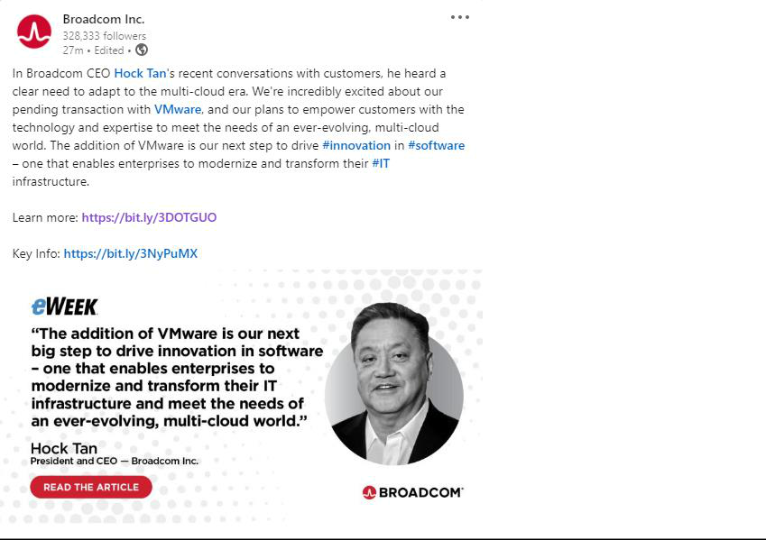

On November 7, 2022, Broadcom Inc. published the following post on Twitter:
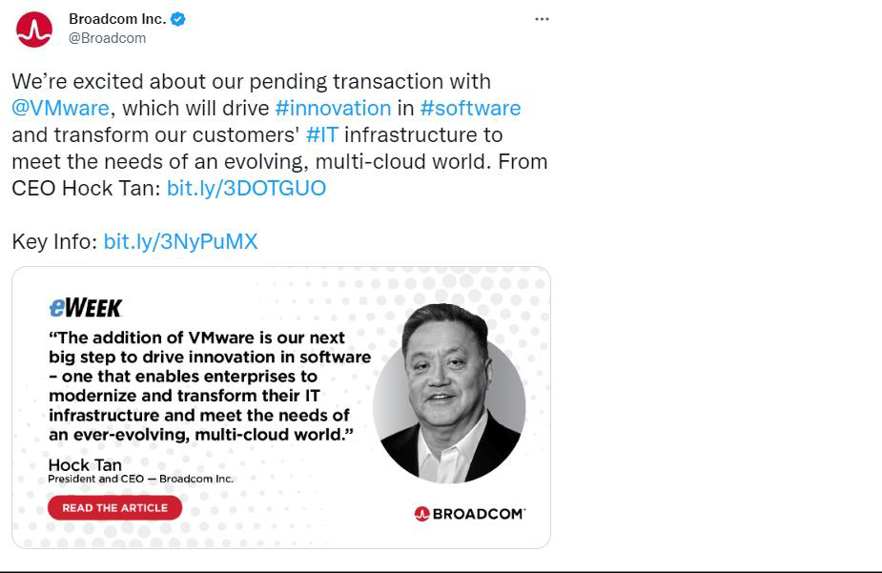

On November 7, 2022, Broadcom Software Group published the following post on LinkedIn:
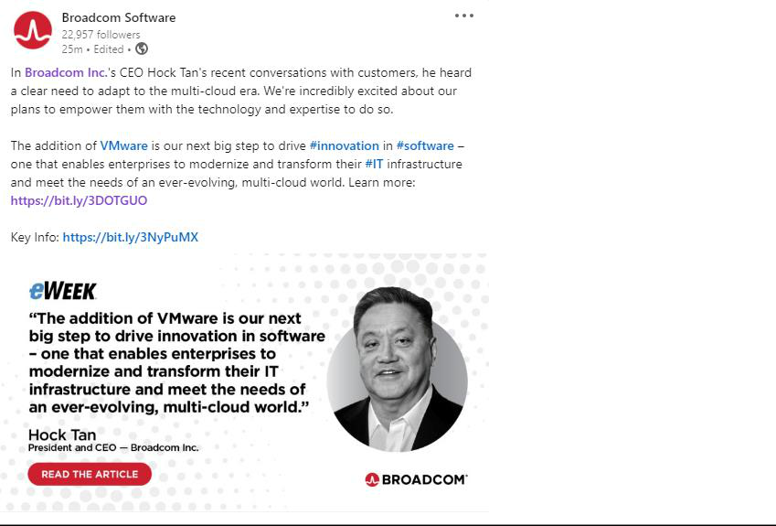

On November 7, 2022, Broadcom Software Group published the following post on Twitter:
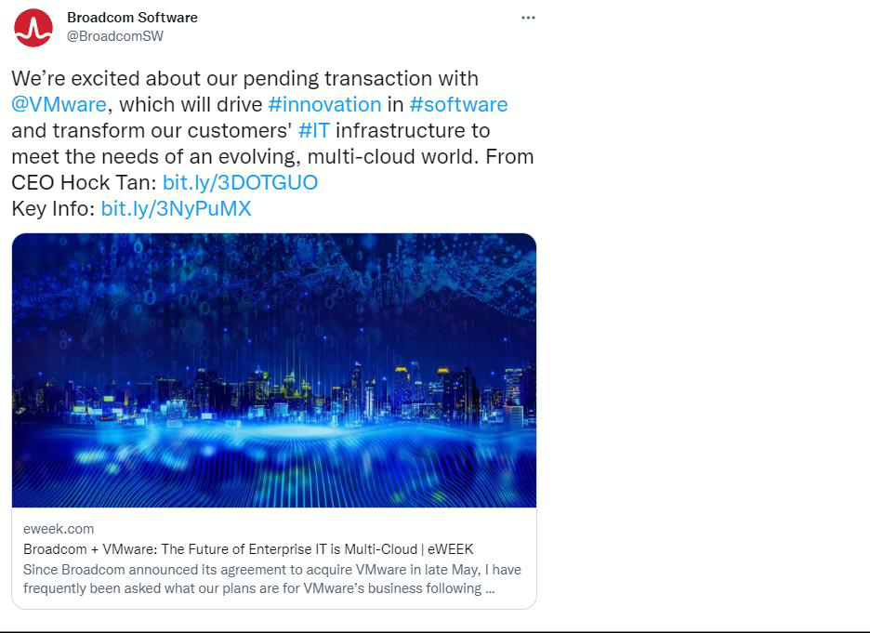

On November 7, 2022, Hock Tan published the following post on LinkedIn:
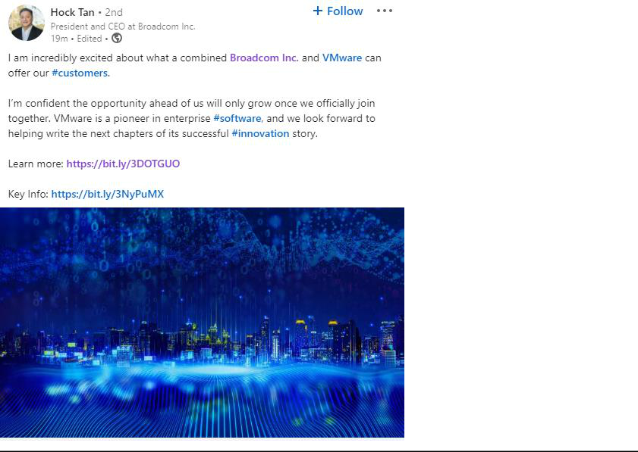

[The text of the article accessible through the link included in the posts above is reproduced below. The article is also available at reimaginingsoftware.com]

Broadcom + VMware: The Future of Enterprise IT is Multi-Cloud

By Hock Tan, President and CEO of Broadcom

Since Broadcom announced its agreement to acquire VMware in late May, I have frequently been asked what our plans are for VMware’s business following transaction close. It’s an important question and one that I continue to consider as we progress through the regulatory review process. Having recently returned from visiting with our customers across the world, it’s the right time to share my current thinking on our plans.

Innovating for the Future

One of our primary reasons for acquiring VMware was based on a recognition that the future of enterprise IT is multi-cloud – the ability to build and distribute applications and services across a combination of clouds.

To take a step back, over the last 15+ years, Broadcom has built one of the leading technology companies in the world through customer-focused R&D as well as acquisitions. Innovation has fueled our growth, with R&D spend outpacing revenue growth by nearly 50% since 2009, and it will remain integral to our long-term strategy.

What drives our commitment to R&D investment is an understanding that we must invest in both short- and long-term customer needs. We must anticipate and continue innovating technology that will help our customers grow their businesses. The addition of VMware is our next big step to drive innovation in software – one that enables enterprises to modernize and transform their IT infrastructure and meet the needs of an ever-evolving, multi-cloud world. VMware has best-in-class technology and talent, as well as a promising roadmap. Solutions from the Broadcom and VMware portfolio will offer customers the broadest set of software to navigate both current and future multi-cloud challenges.

VMware develops technology for the future and addresses a growing market. The Broadcom business case for this transaction is premised on focusing on the business model, increasing R&D, and executing in getting customers to use the full portfolio of innovative product offerings – not on increasing prices.

Building on Solid Foundations

In my recent conversations with customers, I heard a clear need to adapt to the multi-cloud era and shared my excitement about our plans to empower them with the technology and expertise to do so. For customers to become “Cloud Smart,” they will need a connected ecosystem of partners working together to meet their requirements. VMware has built a powerful partner network to support customers’ multi-cloud strategies, and together, we will accelerate its growth and momentum to help customers achieve their business objectives. In addition, the technology leadership of VMware product and engineering teams is outstanding, which Broadcom will continue to support them.

While we will look for opportunities post-closing to further unlock VMware’s potential, our initial focus will be to continue building on all of the pioneering work and partnerships that define VMware today. By applying Broadcom’s operating expertise and proven track record to VMware’s strong partner ecosystem, we can advance our mutual focus on innovation and continue to develop technologies that enable customers to work seamlessly in private and public cloud environments.

By investing and innovating in infrastructure software and VMware’s broad portfolio – including multi-cloud and cloud-native capabilities – we will bring our customers greater flexibility and deliver new solutions to help them connect, scale and protect their IT infrastructure. This will also empower our customers to modernize and architect their IT infrastructure while ensuring there will be large-scale, secure, and reliable, yet flexible, choices to do so.

Investing in Partner Relationships to Benefit Customers

Customers and partners work with Broadcom because of our trusted relationships, consistent execution, operational focus and innovative solutions. As we maintain our focus on creating value for customers, we plan to embrace VMware’s existing partnership ecosystem as a valuable asset for serving customers of all sizes.

VMware’s partner ecosystem is embedded in everything the company does across each point in the value chain and fuels its innovation engine – that’s what makes it successful. Moreover, VMware’s partnership programs, which are continually being updated and evolved, are designed to help partners grow and become more profitable on their own. After the transaction is complete, we will continue to invest in developing our united ecosystem to help partners grow their businesses with expanded offerings of the combined organization and enable them to better meet the needs of their customers.

Today I remain incredibly excited about what a combined Broadcom and VMware can offer our customers. I’m confident this will only grow as we progress toward officially joining together. VMware has created a pioneer in enterprise software, and we look forward to helping write the next chapters of its successful innovation story.

For more information on how Broadcom is innovating for the future with enterprise software, visit our blog at Broadcom Software Blogs.

Cautionary Statement Regarding Forward-Looking Statements

This communication relates to a proposed business combination transaction between Broadcom Inc. (“Broadcom”) and VMware, Inc. (“VMware”). This communication includes forward-looking statements within the meaning of Section 21E of the U.S. Securities Exchange Act of 1934, as amended, and Section 27A of the U.S. Securities Act of 1933, as amended. These forward-looking statements include but are not limited to statements that relate to the expected future business and financial performance, the anticipated benefits of the proposed transaction, the anticipated impact of the proposed transaction on the combined business, the expected amount and timing of the synergies from the proposed transaction, and the anticipated closing date of the proposed transaction. These forward-looking statements are identified by words such as “will,” “expect,” “believe,” “anticipate,” “estimate,” “should,” “intend,” “plan,” “potential,” “predict,” “project,” “aim,” and similar words or phrases. These forward-looking statements are based on current expectations and beliefs of Broadcom management and current market trends and conditions.

These forward-looking statements involve risks and uncertainties that are outside Broadcom’s control and may cause actual results to differ materially from those contained in forward-looking statements, including but not limited to: the effect of the proposed transaction on our ability to maintain relationships with customers, suppliers and other business partners or operating results and business; the ability to implement plans, achieve forecasts and meet other expectations with respect to the business after the completion of the proposed transaction and realize expected synergies; business disruption following the proposed transaction; difficulties in retaining and hiring key personnel and employees due to the proposed transaction and business combination; the diversion of management time on transaction-related issues; the satisfaction of the conditions precedent to consummation of the proposed transaction, including the ability to secure regulatory approvals on the terms expected, at all or in a timely manner; significant indebtedness, including indebtedness incurred in connection with the proposed transaction, and the need to generate sufficient cash flows to service and repay such debt; the disruption of current plans and operations; the outcome of legal proceedings related to the transaction; the ability to consummate the proposed transaction on a timely basis or at all; the ability to successfully integrate VMware’s operations; cyber-attacks, information security and data privacy; global political and economic conditions, including cyclicality in the semiconductor industry and in Broadcom’s other target markets, rising interest rates, the impact of inflation and challenges in manufacturing and the global supply chain; the impact of public health crises, such as pandemics (including COVID-19) and epidemics and any related company or government policies and actions to protect the health and safety of individuals or government policies or actions to maintain the functioning of national or global economies and markets; and events and trends on a national, regional and global scale, including those of a political, economic, business, competitive and regulatory nature.

These risks, as well as other risks related to the proposed transaction, are included in the registration statement on Form S-4 and proxy statement/prospectus that has been filed with the Securities and Exchange Commission (“SEC”) in connection with the proposed transaction. While the list of factors presented here is, and the list of factors presented in the registration statement on Form S-4 are, considered representative, no such list should be considered to be a complete statement of all potential risks and uncertainties. For additional information about other factors that could cause actual results to differ materially from those described in the forward-looking statements, please refer to Broadcom’s and VMware’s respective periodic reports and other filings with the SEC, including the risk factors identified in Broadcom’s and VMware’s most recent Quarterly Reports on Form 10-Q and Annual Reports on Form 10-K. The forward-looking statements included in this communication are made only as of the date hereof. Neither Broadcom nor VMware undertakes any obligation to update any forward-looking statements to reflect subsequent events or circumstances, except as required by law.

No Offer or Solicitation

This communication is not intended to and shall not constitute an offer to buy or sell or the solicitation of an offer to buy or sell any securities, or a solicitation of any vote or approval, nor shall there be any sale of securities in any jurisdiction in which such offer, solicitation or sale would be unlawful prior to registration or qualification under the securities laws of any such jurisdiction. No offering of securities shall be made, except by means of a prospectus meeting the requirements of Section 10 of the U.S. Securities Act of 1933, as amended.

Additional Information about the Transaction and Where to Find It

In connection with the proposed transaction, Broadcom has filed with the SEC a registration statement on Form S-4 that includes a proxy statement of VMware and that also constitutes a prospectus of Broadcom. Each of Broadcom and VMware may also file other relevant documents with the SEC regarding the proposed transaction. The registration statement was declared effective by the SEC on October 3, 2022 and the definitive proxy statement/prospectus has been mailed to VMware’s stockholders. This document is not a substitute for the proxy statement/prospectus or registration statement or any other document that Broadcom or VMware may file with the SEC. INVESTORS AND SECURITY HOLDERS ARE URGED TO READ THE REGISTRATION STATEMENT, PROXY STATEMENT/PROSPECTUS AND ANY OTHER RELEVANT DOCUMENTS THAT MAY BE FILED WITH THE SEC, AS WELL AS ANY AMENDMENTS OR SUPPLEMENTS TO THESE DOCUMENTS, CAREFULLY AND IN THEIR ENTIRETY IF AND WHEN THEY BECOME AVAILABLE BECAUSE THEY CONTAIN OR WILL CONTAIN IMPORTANT INFORMATION ABOUT THE PROPOSED TRANSACTION. Investors and security holders may obtain free copies of the registration statement and proxy statement/prospectus and other documents containing important information about Broadcom, VMware and the proposed transaction, once such documents are filed with the SEC through the website maintained by the SEC at http://www.sec.gov. Copies of the documents filed with the SEC by Broadcom may be obtained free of charge on Broadcom’s website at https://investors.broadcom.com. Copies of the documents filed with the SEC by VMware may be obtained free of charge on VMware’s website at ir.vmware.com.

Participants in the Solicitation

Broadcom, VMware and certain of their respective directors and executive officers may be deemed to be participants in the solicitation of proxies in respect of the proposed transaction. Information about the directors and executive officers of Broadcom, including a description of their direct or indirect interests, by security holdings or otherwise, is set forth in Broadcom’s proxy statement for its 2022 Annual Meeting of Stockholders, which was filed with the SEC on February 18, 2022, and Broadcom’s Annual Report on Form 10-K for the fiscal year ended October 31, 2021, which was filed with the SEC on December 17, 2021. Information about the directors and executive officers of VMware, including a description of their direct or indirect interests, by security holdings or otherwise, is set forth in VMware’s proxy statement for its 2022 Annual Meeting of Stockholders, which was filed with the SEC on May 27, 2022, VMware’s Annual Report on Form 10-K for the fiscal year ended January 28, 2022, which was filed with the SEC on March 24, 2022, a Form 8-K filed by VMware on April 22, 2022 and a Form 8-K filed by VMware on May 2, 2022. Other information regarding the participants in the proxy solicitations and a description of their direct and indirect interests, by security holdings or otherwise, are or will be contained in the proxy statement/prospectus and other relevant materials to be filed with the SEC regarding the proposed transaction when such materials become available. Investors should read the proxy statement/prospectus carefully before making any voting or investment decisions. You may obtain free copies of these documents from Broadcom or VMware using the sources indicated above.

